Modeling biological membranes with circuit boards: Student laboratory exercises

ABSTRACT
This is a demonstration of how electrical models can be used to characterize biological membranes. This exercise also introduces biophysical terminology used in electrophysiology. The equipment used in this membrane model will also be used on live preparations later this semester. Several properties of an isolated nerve cord are investigated including: nerve actions potentials, recruitment of neurons, and responsiveness of the nerve cord to environmental factors.
1.1) Background
A fundamental knowledge of electrical circuits is a valuable tool for understanding and conceptualizing many aspects of physiological experimentation and theory. This exercise is intended to acquaint you with some general principles involving voltage sources, electrical resistance, and electrical capacitance. These introductory concepts provide the background for understanding such phenomena as synaptic transmission and the spread of electrical signals along a nerve fiber.
A word of caution: In standard everyday electrical circuits composed of metal wires and resistors, current is carried by electrons, which have a negative charge. In biological systems however, current is carried by IONS, which may have one or more positive or negative charges. By convention, current flows from positive to negative (although, of course, electrons actually move the other way).
The components of the circuit represent the electrical properties of living tissue, and in some cases, that of inanimate objects (i.e. electrodes) involved in its study.
In working through the exercise, keep notes of results and calculations.
1.2) General Principles
The basic properties of electrical circuits in which direct current flows are described by Ohm’s Law
$$V=IR$$
Where V is voltage in volts (V), I is current in amps (A), and R is resistance in ohms (Ω)
This law governs the potentials which are observed in nerve cells with electrodes. We will first demonstrate Ohm’s Law and its application in biological materials.
1.3) Materials
Item |  |  | Quantity
Breadboard |  |  | 1
Resistors | : 330 K Ω |  | 1
 | : 100 K Ω |  | 12
 | : 33 K Ω |  | 6
 | : 22 K Ω |  | 1
 | : 10 K Ω |  | 6
 | : 4.7 K Ω |  | 1
 | : 2.2 K Ω |  | 1
 | : 1.5 K Ω |  | 1
 | : 1 K Ω |  | 1
 | : 510 Ω |  | 1
 | : 330 Ω |  | 1
 | : 220 Ω |  | 1
 | : 150 Ω |  | 1
 | : 100 Ω |  | 1
Capacitors |  | : 0.10 µF | 6
 |  | : 10.0 µF | 6
Wires |  |  | 12
PowerLab |  |  | 1
PowerLab Output Leads |  |  | 1
PowerLab Input Leads |  |  | 1
Voltmeter (Current Capable) |  |  | 1

Resistor Coding Key
Color | Digit
Black | 0
Brown | 1
Red | 2
Orange | 3
Yellow | 4
Green | 5
Blue | 6
Violet | 7
Grey | 8
White | 9
Silver | 10% Tolerance
Gold | 5% Tolerance
1st Band – 1st Digit
2nd Band – 2nd Digit
3rd Band – Number of Zeros
4th Band – Tolerance

Figure 1: System Setup. Computer, bread board and power lab with output stimulator. Stimulator cable is the black cord, the one with red tape goes in the positive one.

The PowerLab system (PowerLab interface from AD Instruments, Australia) will serve as the voltage source in this experiment.
- Attach the PowerLab’s USB cable to the computer, turn on the PowerLab, and open the LabChart 7 program from the desktop.
- Select “New File.”
- A window will appear with multiple recording channels. Select “Setup” at the top and click on “Channel Settings.” In the bottom left corner of the window, decrease the Number of Channels to 1; on Channel 1, change the Range to 5 V.
- Connect the Stimulator cable with the two mini-hook leads to the Output portals on the PowerLab as follows: attach the red connector cable to the positive Output portal and the black connector cable to the negative Output portal.
- Next, it is necessary to change the power output, frequency, and pulse duration of the PowerLab. In order to do this, select “Setup,” and then “Stimulator Panel.” Long pulses of 1.5 V are required for the first portion of the experiment, so adjust the amplitude (pulse height) to 0.75 V; this will give a range of 1.5 V (the PowerLab will emit a voltage fluctuating between positive and negative 0.75 V). Set the frequency (max repeat rate) (0.5 Hz) and pulse duration (pulse width) (1 sec). Turn stimulator on.
Figure 2: Breadboard schematics. The color strips along the sides are all connected as one unit for a given color. The two horizontal columns in the center are connected on each half for a given row, but do not cross over the midline or to the side strips. Each row in the middle is independent of the next row.
When using a breadboard there are two columns on either side used for the input and output leads. Positive is generally connected to the right positive column in which all of the spaces in the column are connected. Negative input is connected to the opposite side of the breadboard where, again, all of the spaces in a column are connected. In the middle, between the two sets of columns, are multiple rows of five cells, each of which is independent of the others. All of the cells in a row of five are connected to one another, but isolated from the other rows. Refer to Figure 2. The highlighted regions show what parts of the breadboard are interconnected. A useful video on breadboard use can be found online at
http://www.youtube.com/watch?v=oiqNaSPTI7w&feature=related
Exercise 1
Use Ohm’s Law to calculate the CURRENT flowing through the following circuit:
1.5 V
1500 Ω
NETWORK 1
Current (Network 1): ____________A
Exercise 2
Measure the voltage across the resistor, the resistance of the resistor, and the current flowing through the above circuit (Network 1).
Figure 3: Wavetek Meterman voltmeter
Recreate Network 1 on the breadboard using a 1500 Ω resistor. The PowerLab serves as the voltage source (1.5 V). Measurements of voltage, current, and resistance are made with the Voltmeter. In order for the Voltmeter to gather accurate data, both the red and black probes must be in contact with bare wire in circuit. Also, the dial should be adjusted to “DC Voltage” in a range appropriate for the scale of any individual experimental setup.
- For the voltage measurement, touch both probes of the voltmeter across the two ends of the resistor (the voltmeter is in parallel in this circuit).

Voltage (Network 1): ________________V
- When measuring the resistance of the resistor (not the voltage drop), DISCONNECT the voltage source and, again, touch both probes across the resistor.

Resistance (Network 1): ________________Ω

- To measure current, the voltmeter must be in SERIES in the circuit. Break the circuit and add the voltmeter as part of the circuit. *Take note that the red and black probes must be oriented properly in reference to the current flow. The current might be too low to measure with your voltmeter. If so calculate the current you would expect from the measure of V and R.

Current (Network 1): ________________A

Now with the Power Lab measure the voltage across Network 1, just as you did with the voltmeter.
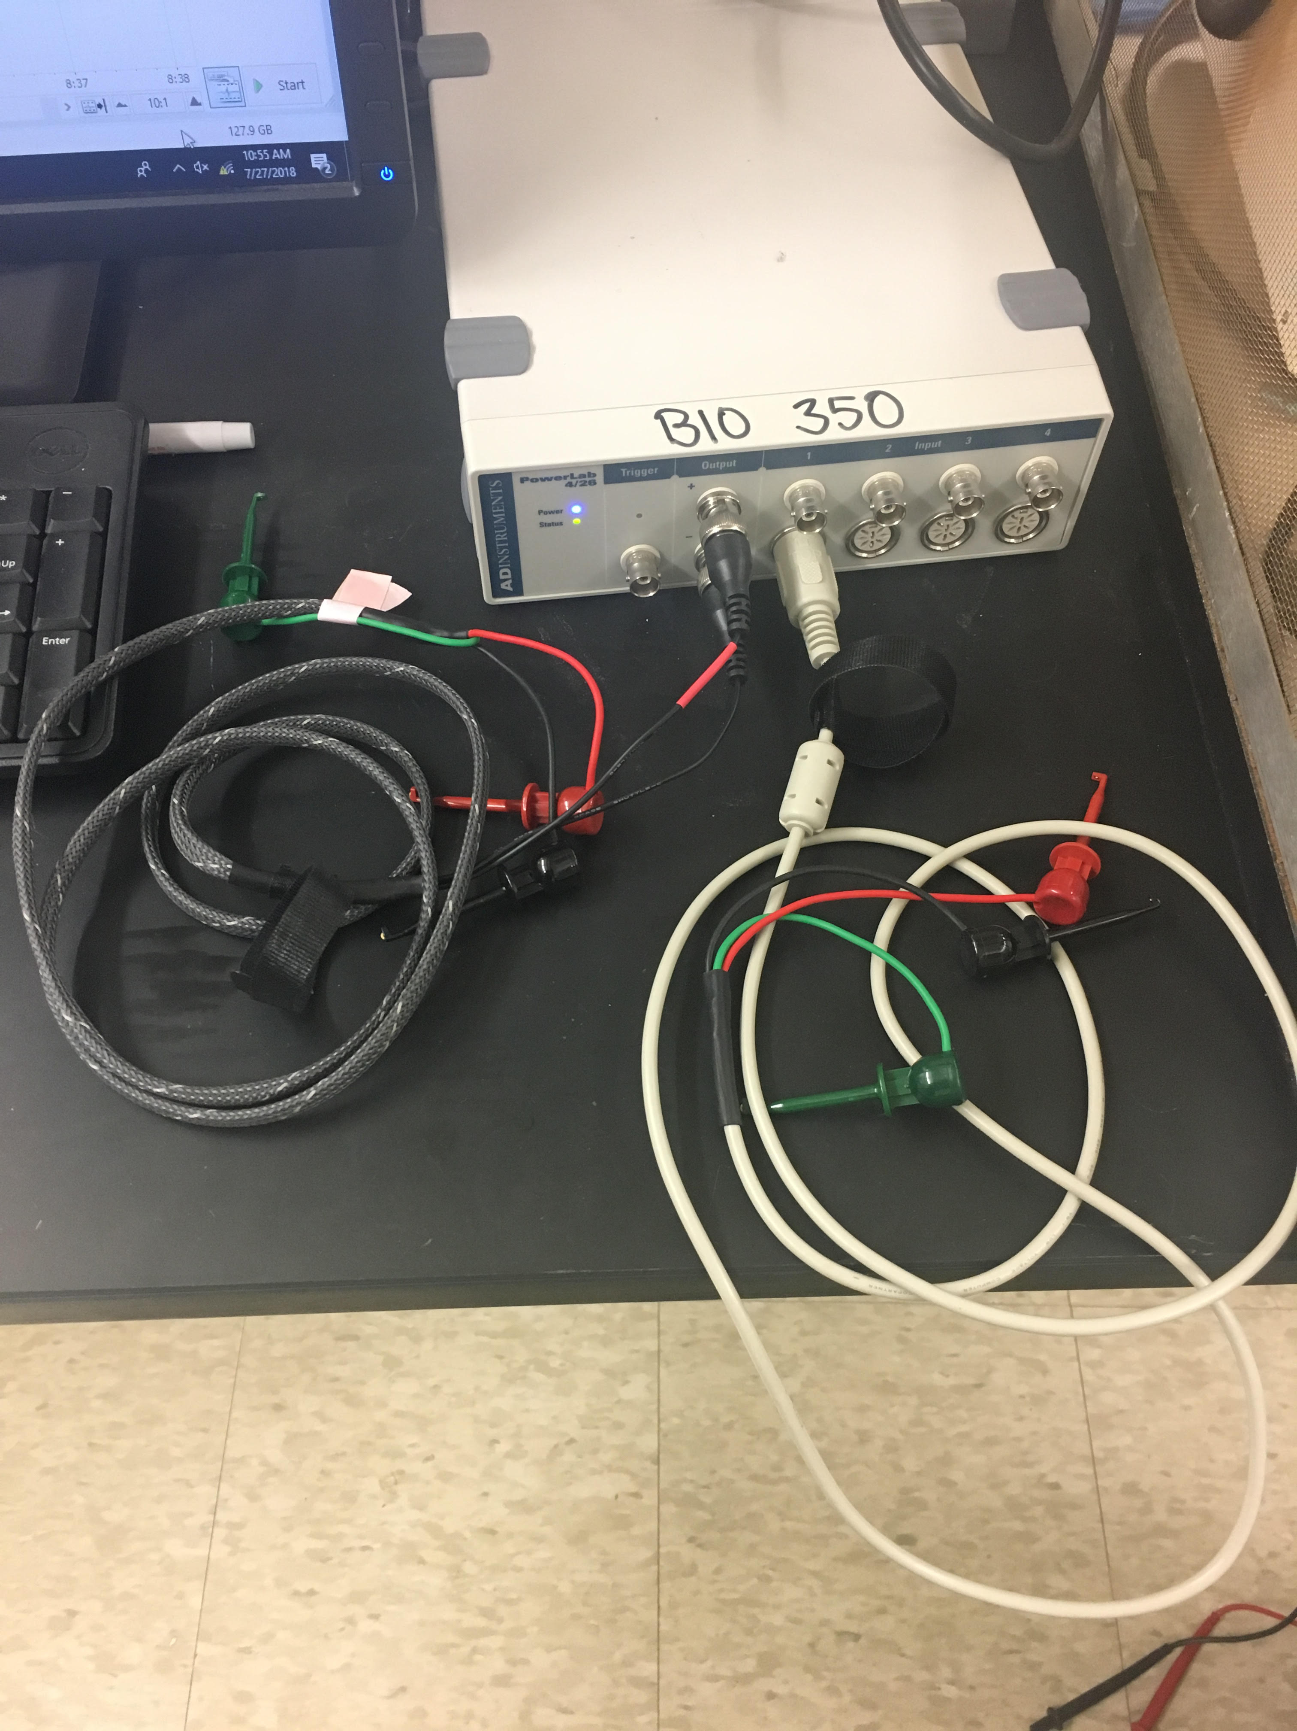
Voltage measuring probe (white).
- Disconnect the voltmeter and connect the leads for the voltage-measuring probe with the red and black clips. Leave the stimulating probes attached.
- Open up Lab Chart 7. This can be found using search function under ‘programs.
- Close all channels except “Channel 1” under “channel settings.” At the bottom of the page change to 1 channel.
- Next, proceed to use the cursor to click on “Channel 1” (right hand side of screen).
- Click and go to “input amplifier”.
- Then, in the box, click on the “differential” button and set range to 200 mV. Click “OK” to save changes.
- Click on “Start” (lower right hand corner) to collect data. One can stop at any time to measure the voltage deflections.
- To measure the voltage collected, click “Stop” and use the “M” cursor (lower left corner) and move it to the baseline by dragging it over.
- Then, place the free cursor on the top of the voltage trace to measure the amplitude. Read the change in voltage (ΔV) and record the data below. You can confirm the results with the stand-alone voltmeter.
Change in voltage (ΔV)= ________________V
1.4) Resistance and Conductance in Series
Principle of the Voltage Divider: For resistors in series, the sum of the voltage drops across each resistor is equal to the voltage of the source. The voltage across each individual resistor depends on the fraction of the total resistance that resistor represents. Hence:
$V_{1}= V_{(source)}\frac{R_{1}}{R_{1}+R_{2}}$
A pair of resistors will divide a voltage in the ratio of their individual resistances.

Exercise 3

Calculate the voltage drop across each resistor in Network 3. Check your calculations by measuring the actual voltage with your voltmeter and power lab software, with the 1.5 V source connected. Use the measurement leads on the resister to measure the voltage across that resistor.
1.5 V
$R_{1}$: 510 Ω
NETWORK 3
$R_{2}$: 1500 Ω
NETWORK 3. Use the two resistors indicated above.
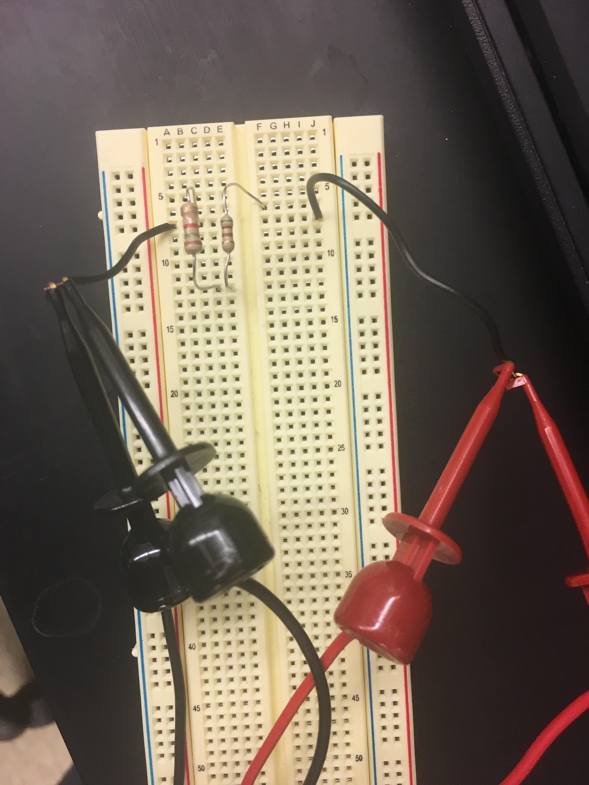
$$V_{1}= V_{(source)}\frac{R_{1}}{R_{1}+R_{2}}$$
Calculated: | Measured:
Voltage (Across R₁): ________V | Voltage (Across R₁): ________V
Voltage (Across R₂): ________V | Voltage (Across R₂): ________V

1.5) Sample Biological Application:
The differing electrical properties of the cell interior and the external solution of an active nerve cell provide an example of a voltage divider. This biological circuit can be explored through recordings taken with external electrodes. The active region of the nerve cell, where ions enter, acts as a voltage source. Current flows from this region along the interior of the cell and returns through the external solution. Thus, between two points of the membrane that differ in potential, there is a current flow. Of necessity, this current flow is the same inside the fiber as outside the fiber. Since the resistance of the inside is larger than that of the outside, the greatest voltage drop occurs here.
Consider the system and its equivalent circuit (Figure 4: A. and B.):
Oscilloscope
_ _ _ _
_ _ _ _
+ + + +
+ + + +
Nerve Cell
$R_{0}$: Current Flowing Through External Resistance
$R_{i}$: Current Flowing Through Internal Resistance
A
B
Equivalent Circuit:
Oscilloscope
120 mV
A
B
$$R_{0}$$
$$R_{i}$$

Figure 4: A (top). The electrical flow of current across a biological cell membrane. B (bottom). Equivalent electrical circuit. The voltage source (120 mV) is the transmembrane voltage generated by the nerve cell’s action potential.
Note: R₀ and R_{i} are actually in series (not in parallel) due to the position of the power source. An equivalent drawing of the circuit is as follows:
Oscilloscope
120 mV
$$V_{0}$$
$R_{0}$: 1x10⁴ Ω
$R_{i}$: 1x10⁶ Ω
Figure 5: Alternate equivalent electrical circuit for Figure 4A.
Exercise 4.
Given that:
$$V_{0}= V_{(m)}\frac{R_{0}}{R_{0}+R_{i}}$$

V_{m}, potential across membrane = 120 mV
R_{i}, resistance of internal fluid = 10⁶ Ω
R₀, resistance of external fluid = 10⁴ Ω
Calculate V₀, the potential between electrodes A and B.
V₀: ________________V
Exercise 5.
Using Network 4 (see below), measure the potentials across each resistor (R₀ and R_{i}).
NETWORK 4. Connect 4.7 K Ω and 10 K Ω resistors in series with the 1.5 V source:
1.5 V
$R_{0}$: 4.7 K Ω
NETWORK 4
$R_{i}$: 10 K Ω
Measure voltages with your voltmeter.
Voltage (Across R₀): ________________V
Voltage (Across R_{i}): ________________V
NETWORK 5 : Same as Network 4, except R₀ = 1 K Ω
Note that in Network 5, the external resistance is much lower (like in a saline bath shunting the electrodes), hence the importance of recording from nerves in air or under insulating oil, to increase the external resistance.
Voltage (Across R₀): ________________V
Voltage (Across R_{i}): ________________V
Exercise 6
An example of series-parallel resistive network occurs when considering the cable properties of the nerve or muscle fiber. The length constant of a fiber is that distance over which a potential difference (PD) across the membrane declines to 37% of its original value. The attenuation is due to the internal and external resistances of the fluid on either side of the membrane being shunted by the (relatively high) transverse membrane resistance. The value of the resistance limits the transfer of a signal along a nerve cell’s axon. The length constant is 1/e as measured for an exponential decay:
$$\frac{dE}{dT}=\frac{-E}{RC}$$
where E is the voltage difference, R is resistance and C is capacitance. Or in another form,
$$E=E_{0}exp⁡(\frac{-t}{RC})$$
where E_{o} is the starting voltage and t is time in seconds. RC is also referred to as tau (τ), the time constant.
Assuming the resistance of the external fluid to be negligible in comparison to the intracellular and membrane resistances, the passive resistive properties of the membrane can be represented by the following circuit:
$$R_{M}$$
NETWORK 7
A
B
$$R_{i}$$
$R_{M}$: 33 K Ω
$R_{i }$: 10 K Ω
1 2 3 4 5 6
Unit Distance for Length Constant Calculations
Len
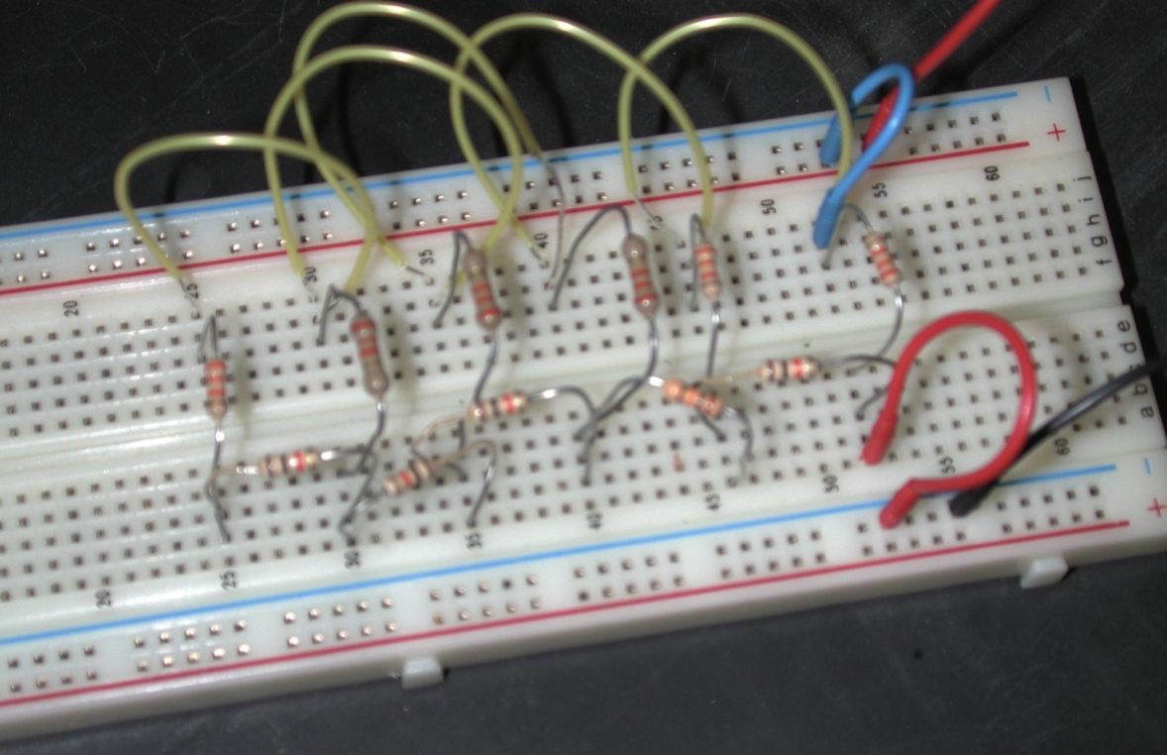
Figure 7: Translation of Network 7 onto breadboard setup
- Apply a voltage at one end of Network 7 between A and B.
- Using a stimulator, select a pulse of 1s duration, 1V amplitude (set to 0.5 V) and frequency at 0.75Hz.
- Connect the voltmeter across each “membrane” resistor in turn, and note the potential difference (PD) across that resistor.
- Leave one end of the voltmeter probe stationary at (A-lead, Red) while the other lead is moved successively along locations1-5.
- Record the data in the table below.
- Plot each value on a graph of PD against distance from the source, with the membrane resistors being unit distance apart. From your graph determine the length constant of this circuit. Remember length constant is defined as 37% of initial voltage.
Distance (units) | Voltage (V)
1
2
3
4
5
6

1 2 3 4 5 6
Length Constant:______________ unit length
An increase in transverse membrane resistance (as would occur with a myelin sheath) or a decrease in longitudinal internal resistance of the fiber (associated with an increase in fiber diameter) changes the value of the length constant. The values of resistance are not those actually found in a nerve axon, but are approximately proportional. Likewise, the "unit distance" on the model is substantially scaled up from a real nerve cell.
DO NOT disassemble the membrane you made above until after the capacitors experiments below. So work on the other side of bread board for the next procedure
1.7) Capacitance
Capacitors store charge. If a voltage is applied to a capacitor in series with a resistor, current flows into the capacitor, and then the potential difference (PD) across the capacitor rises exponentially with time toward the PD of the source. The time course of this voltage change is dependent on the applied voltage, the capacitance, and the series resistor. A similar but inverted time course is seen when a capacitor discharges.
A
B
10 μF
100 K Ω
NETWORK 8
- Connect the input of this simple Resistor-Capacitor (RC) network to your stimulator at A and B.
- Use 1V (set to 0.5V) pulses with a 1 s duration and frequency of 0.75Hz. Also, one must set the acquisition to 20 K /sec (right hand side of panel).
- Connect your input clamps from the PowerLab across the capacitor and resistor together. Collect data for a few seconds and then stop.
- Use the “Zoom” window to expand the rise time on one of the square pulses. The zoom in might have to be repeated a few times to spread out the trace. Measure the rise time from baseline to the top of the voltage trace, just as it levels off. Observe the time course of potential change (removed a comma here) as well as the distortion of the square pulses.
Time to peak: ________
- Observe the effect of changing the 10 $μF$ capacitor for a 0.1 $μF$ capacitor. By connecting your power lab volt probe across the resistor, you can observe the time course of current flow through the circuit. Collect only a few pulses and then stop to measure. Use the “M” cursor to move to the base line prior to the rise and the free cursor to where the voltage begins to levels off.
Time to peak: _______

The last example involves both resistive and capacitative components. The passive cable properties of nerve and muscle fibers are determined by similar elements, arising from cell membrane properties. Not only is there a transverse membrane resistance present in the cell, but also a membrane capacitance due to the electrical properties of the cell membrane. The effect of this is to alter the time course of the development of electrotonically spread potentials.
Example:
NETWORK 9
This network can be constructed from Network 7 by attaching the required capacitors in parallel to the membrane resistors (R_{M}).
Exercise 7.
- Attach the 10$μF$ capacitors to Network 7. Using 1s, 1V (0.5 V setting) and 0.75Hz pulses from the stimulator, which should be connected at A and B, observe the potential changes across each membrane resistor.
- Assuming the “threshold” voltage (the voltage at which an action potential is generated in a nerve cell) to be 0.2V, measure the time taken for the potential to reach threshold at each membrane resistor. Here, threshold means the potential value at which an action potential can be generated in a living cell.
- Record your data in the table below.
Distance (unit) | Time to reach 0.2 V (ms)
1
2
3
4
5
6

Figure 8: Translation of Network 9 onto breadboard setup
- Simulate the effect of a decrease in membrane capacitance produced by an increase in thickness of the myelin sheath by substituting the 10$μF$ capacitors with the smaller 0.1$μF$ capacitors.
- Assuming the “threshold” voltage to be 0.2V, measure the time taken for the potential to reach threshold at each membrane resistor.
- Record your data in the table below.
Distance (unit) | Time to reach 0.2 V (ms)
1
2
3
4
5
6

- Plot your results for the 10$μF$ capacitors as time against distance (or unit length). Superimpose the data for the 0.1 $μF$ capacitors on the same graph below.
1 2 3 4 5 6
Determine the unit length where the threshold (0.2V) is not reached:
With 10$μF$ capacitor: _______________ | With 0.01 $μF$ capacitor: _______________

Conclusion:
In terms of a muscle membrane, one can think of an increased capacitance due to an increase in the surface area of the membrane by the associated T-tubules. These T-tubules essentially result in a larger membrane capacitance as compared to a neuron because they effectively increase the surface area of the cell membrane. In other words, because muscle cells possess T-tubules that increase the area of the cell membrane, but neurons lack these T-tubules, muscle cells possess a larger capacitance. Smaller capacitors can be used to illustrate the decreased capacitance due to addition of myelin to an unmyelinated nerve axon. The main point here to learn is that the electrical capacitance is proportional to surface area and inversely related to the thickness of the dielectric layer (myelin) which separates the "plates" or storing surfaces of the capacitor.
The properties observed on a model circuit are observed in live preparations. However, cells vary in their properties such as leakage across the membrane and axial resistance. Some cells do not generate action potentials. However, an action potential is produced when a signal must be transmitted over a few millimeters because passive electrical properties of cells attenuate signals over this distance. In the next series of experiments the recording of actions potentials is illustrated.

1.8) Questions for the students
1. What are some normal values of length constant for neurons and muscle cells?

2. What if a membrane had a low membrane resistance: would the time constant (time to reach 63% of final value) change? If so, how would it change with a lower membrane resistance? What is the generalized mathematical formula for time constant (tau)?

3. Why is it that larger axons, such as the squid giant axon, can conduct electrical signals faster than smaller axons in the same squid preparation?

2) CONDUCTION PROPERTIES OF NERVE CELLS
2.1) From a bread board to living cells
The passive properties demonstrated in the circuit board exercises are also measurable in living cells; however, these passive properties can be complicated to tease out when accompanied with action potentials in nerve cells. The active properties of the neuron include its ability to maintain a resting membrane potential, generate action potentials, and regenerate them along a length of membrane.
Electrical flow along a nerve cord can also be regenerative within individual neurons and from one neuron to the next. In the crayfish ventral nerve cord (VNC), some neurons communicate via septate (i.e. gap) junctions. As demonstrated in the earlier exercises with the bread board, altering the resistance can impede conduction of electrical signals. This is analogous to altering the flow of current through gap junctions within the ventral nerve cord.
The conduction velocity and other properties of the compound action potential in the VNC are examined in the next series of experiments. We will demonstrate how to obtain the VNC for experimentation. The VNC will also be used to elicit and measure responses using standard equipment designed for teaching student laboratories.
Acknowledgments

These experiments were modified from a laboratory manual that has been used in a course, orchestrated by Dr. H.L. Atwood, at the Department of Zoology, University of Toronto. The exercises were also used and modified from a manual that was produced for “6th INTENSIVE IBRO WORKSHOP ON BASIC NEUROSCIENCE” and was held at Korea University, Seoul, South Korea in 1993 (Cooper et al., 1993). The current modifications were required to use equipment common to present day student directed laboratories at various universities. With appreciation to Ms. Alexandra Stanback and Ms. Ashley K. Buchanan (Univ. of KY) for editorial comments.

REFERENCES
Bennett, M. V. L., Barrio, L. C., Bargiello, T. A., Spray, D. C., Hertzberg, E. and Sdez, J. C. (1991). Gap junctions: new tools, new answers, new questions. Neuron. 6: 305-320.

Bernardini, G., Peracchia, C., and Peracchia, L.L. (1984) Reversible effects of heptanol on gap junction structure and cell-to-cell electrical coupling. European Journal of Cell Biology. 34(2):307-312.

Cooper, R.L., Chang, J.J., and Ito, M. (1993) A report on the, "SIXTH INTENSIVE IBRO WORKSHOP ON BASIC NEUROSCIENCE", held in July 1993, Seoul, South Korea. Abstracts, Society for Neuroscience 19:116.3

Cragg, B.G. and Thomas, P.K. (1957). The relationship between conduction velocity and the diameter and internodal length of peripheral nerve fibers. Journal of Physiology. 136: 606-614.

Erlanger, J. Gasser, H.S. and Bishop, G.H. (1924). The compound nature of the action current of nerves as disclosed by the cathode ray oscillograph. American Journal of Physiology 70: 624-666.

Furshpan, E. J. and Potter, D. D. (1959). Transmission at the giant motor synapses of the crayfish. Journal of Physiology. 145(2): 289-325.

Johnston, M. F., Simon, S.A., and Ramrn, F. (1980) Interaction of anesthetics with electrical synapses. Nature (Lond.). 286:498-500.

Loewenstein, W. R. (1966). Permeability of membrane junctions. Annual NY Academy of Sciences 137: 441–472.

Meda, P., Bruzzone, R., Knodel, S. and Orci, L. (1986) Blockage of cell-to-cell communication within pancreatic acini is associated with increased basal release of amylase. Journal of Cell Biology. 103(2):475-483.

Peracchia, C. (1990). Increase in gap junction resistance with acidification in crayfish septate axons is closely related to changes in intracellular calcium but not hydrogen ion concentration Journal of Membrane Biology. 113 (1): 75-92.

Peracchia, C. and Dulhunty, A. F. (1976). Low resistance junctions in crayfish: structural changes with functional uncoupling. Journal of Cell Biology. 70: 419-439.

Peracchia, C., Bernardini, G., and Peracchia, L. L. (1983). Is calmodulin involved in the regulation of gap junction permeability? Pfügers Arch 399: 152–154.

Peracchia, C., Lazrak, A. and Peracchia. L. L. (1994). Molecular models of channel interaction and gating in gap junctions. In Handbook of Membrane Channels. Molecular and Cellular Physiology. C. Peracchia, editor. Academic Press, San Diego. 361-377.

Spray, D. C., Harris, A. L. and Bennett, M. V. L. (1981). Gap junctional conductance is a simple and sensitive function of intracellular pH. Sciences NY 211: 712-715.

Spray, D.C., Harris, L.L. and Bennett, M.V.L. (1982). Comparison of pH and Ca dependence of gap junctional conductance. In Intracellular pH: Its Measurement, Regulation, and Utilization in Cellular Functions, R. Nuccitelli and D. Deamer, eds., pp. 445-461, Alan R. Liss, New York. pp. 445-461.

Spray, D.C., White, R., De Carvalho, C., Harris, A.L. and Bennett, M.L.V. (1984). Gating of gap junction channels. Journal of Biophysics 45: 219-230.

Watanabe, A., and Grundfest, H. (1961). Impulse propagation at the septal and commissural junctions of crayfish lateral giant axons. Journal of General Physiology 45: 267-308.

Wiersma, C.A.G and Hughes, G.M. (1961). On the functional anatomy of neuronal units in the abdominal cord of the crayfish, Procambarus clarkii. Journal of Comparative Neurology 116: 209-228.

